New York city sights
Match the names with the sights and the description
Statue of Liberty Brooklyn Bridge Times Square Central Park
Empire State Building Chrysler Building Rockefeller Centre The High Line
Wall Street Broadway

a)  b) 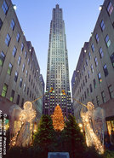 c) 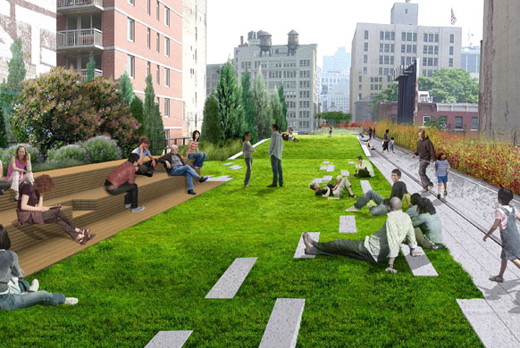
d) 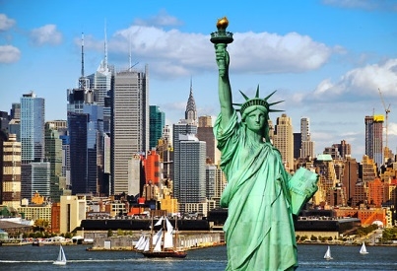 e) 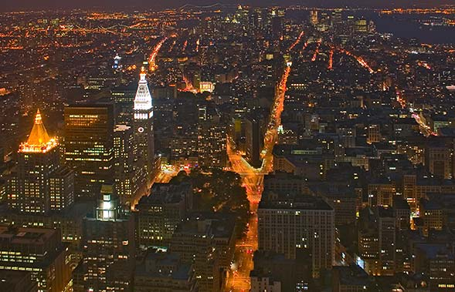 f) 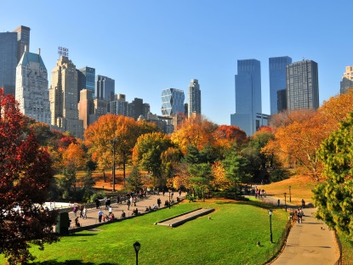
g) 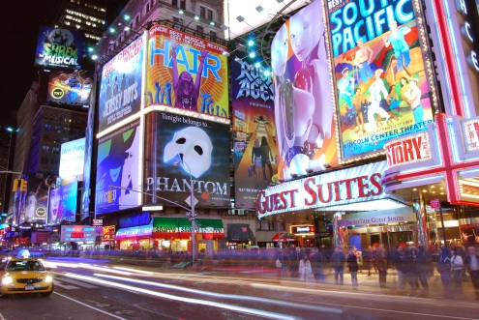 h) 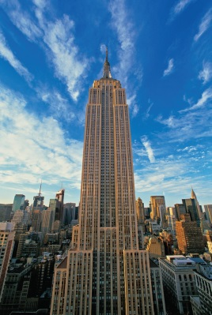 i) 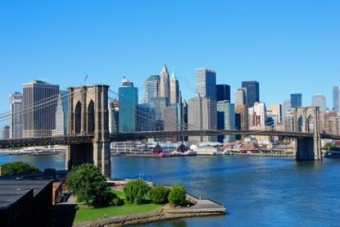
J) 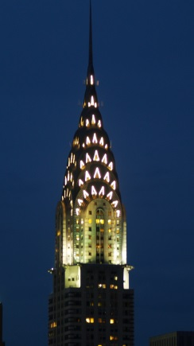

A) This statue was designed by a French sculptor and the French people sent it to the USA for the 100th anniversary of the America´s independence (nezávistlost). The statue is made of copper (měď). It is green because when copper is in contact with the air it turns into green colour.
B) This structure connects Manhattan with New York´s borough Brooklyn and it is named after this borough. It is about 1.8 m long. There is a footpath for walkers and there are also lanes for the traffic.
C) This building is a skyscraper that was named after a car manufacturer Walter Chrysler. It has a very beautiful tower and inside there are offices.
D) This is a complex of commercial buildings that was built by the Rockefeller family. It is popular with tourists because there is an observation deck called the Top of the Rock. When you climb up to the deck, you can see the whole city of New York. In front of the main building, in winter season, there stands a Christmas Tree and the area turns into an ice-rink, so that New Yorkers can come there to enjoy ice-skating.
E) This is a tall building that was built in 1931 and it was the tallest building in New York. Now it is a popular tourist place and you can go and visit the observation deck on the 86th floor and get an amazing view of the city during the day or at night.
F) This is a small square famous for its neon signs, electronic billboards and it is also the centre of theatres and cinemas.
G) This is a huge green area in the centre of New York. There are many lakes, theatres, fountains and sportsfields. In winter the lakes turn into ice-rinks. There are also many statues. There is also a spot where John Lennon was killed when he went jogging to the park one day in the morning. On this place there is a mosaic circle with the inscription “Imagine” – it was a song that was written by John Lennon.
H) It is an old railroad that was built in 1860s. When the railroad was closed, many wild plants and grass started to grow there. Then the railroad turned into a park and now you can have a walk there, sit on the benches and enjoy the beautiful view.
I) This is the financial centre of New York and the world. There is the famous New York Stock Exchange (burza). The street has its name after the wall that once stood there. This wall was a protection against the Native Americans who lived there. The wall was built by the Dutch.
J) This street is a long street that runs through the Manhattan island. It is the oldest street in New York and now it is the cultural centre of NY because many cinemas and theatres are there.

